TUTORIAL #1 - INTRODUCTION
- Open Shogun Live
  - Processing Panel will open
- Top-right there is a “Saved View” layout of different configurations
  - Top-right of the live “window”
    - There is the option to split the screen into different horizontal/vertical layouts
- In the sections:
  - Center
    - 3D workspace
      - Top left of “Workspace”
      - 3D scene, View settings, Camera Position (Front, right, left, back, etc.)
  - Clicking “3D Scene” >> Cameras (opens all of the active cameras)
    - Clicking within one of the camera views will make it Full-screen
      - Change/Tweak the “View Settings”
  - Left
    - System, Subject, Processing
  - Right
    - Camera Calibration
    - Subject Calibration
    - Capture
- Bot-Left there are 3 choices:
  - System
    - Covers Devices that are included in the Mocap System
  - Subject
    - Has a list of subjects
    - Has a list of props
      - Expanding the list will
        - Show list of markers and bones
        - Can also alter the mesh colors
  - Processing
    - Make real-time adjustments of data that is seen in the viewport
- On the Right side:
  - Camera calibration
    - Masking
    - Waving the “Wand”
    - Setting the “Floor Plane”
  - Subject Calibration
    - Ability to capture props
    - Manage Clusters
    - Calibrate Performance
  - Capture Panel
    - Set up capture location
    - Add notes to any captures that you make
    - Trigger external devices
- On the Bot-Right:
  - Data Capture Panel
    - Start/Stop Capture

TUTORIAL #2 – SETTING UP PROP CAPTURE
- Create Database
- Add clusters to Datastore
- Prepare Props
- Set Data level

- CREATE DATABASE
- Open Vicon Shogun Post
  - Click on the “Panels” tab (along the top)
    - Click on “Data Management”
  - –OR click Vicon Eclipse
- Under the “data management” tab that opens:
  - Click the “New” database icon (looks like paper)
  - Choose a location
    - Scratch / Personal / Etc.
    - Give it a name…
      - Give it a description…
  - CHOOSE >> SHOGUN ANIMATION TEMPLATE
    - “Create”
    - It will re-open a database selection tab
      - Choose the database file you just created…
  - You will see nothing on your database for the moment…
    - Right-click in the spreadsheet area
      - Select “New”
        - Give it a name…(My Project)
          - Right click on “My Project”
          - New >> Capture Day
            - Day 1, Day 2, Day 3, etc.
            - Right click on “Day 1”
              - New >> Session
                - Give it a name…(AM / PM)
      - Should see all of your folder structure in your File Explorer now…
- Open Shogun Live
  - Top-right
    - “Capture”
      - Select the “Capture Folder”
        - Navigate to where you created your (AM / PM) folder

- ADD CLUSTERS
  - Open Shogun Live
  - Navigate to Subject Calibration (top-right)
  - Either 4-5 clusters on a marker
    - Place them within the capture area
    - Click:
      - Alt + Drag overtop the markers
      - Click:
        - “Create Cluster”
        - Rinse / Repeat process as necessary
    - If you click:
      - “Manage Clusters” (above Create Cluster)
        - Will show you all of the other Clusters
    - Rename your Cluster >> Manage Cluster
      - Right-Click >> Rename Cluster
- PREPARE PROPS
  - If you have:
    - Long/thin prop:
      - Place markers at the top/bottom for the ability to orient the bones
      - Place more markers along the sides of the object for consistency
    - Bulbous/round prop:
      - Place markers strategically to make sure you know what side of the object is up/down/left/right
    - Thin/Disk
      - Place markers along edges
        - Notate how you want the orientation to be created. (Like the bulbous prop)
  - Imagine a Katana…
    - Within Shogun Live
      - Select the Base Bone (1) + Top Bone (2) [Shift click – DO THIS IN ORDER OF “BASE” TO “END”]
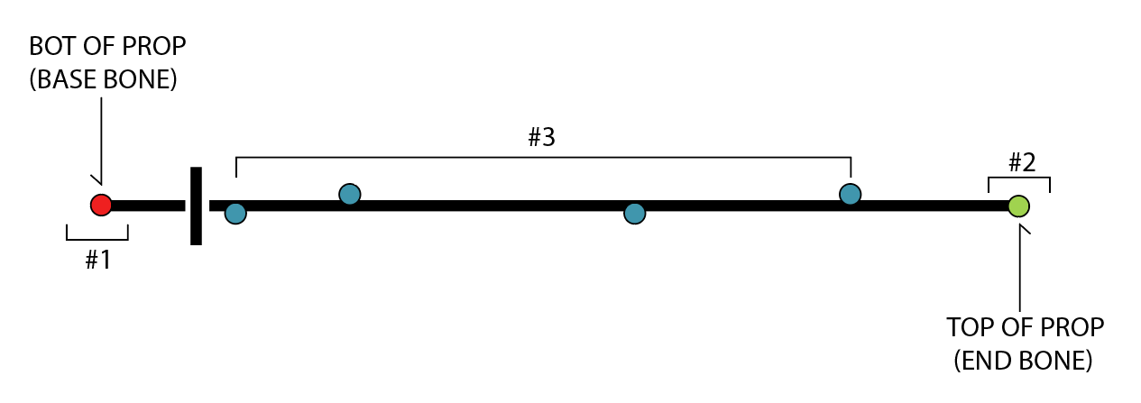
    - Now select the rest of the points
    - Give your prop a name…
      - Then click “Create Prop”
      - Ready for capture!!

- SET DATA LEVEL
  - Click into the Processing tab (bot-left)
    - Processing Output Level (top-left)
      - Reconstruct, Label, Solve
    - ALWAYS ALWAYS ALWAYS CHECK YOUR OUTPUT LEVEL
      - Reconstruct
        - Will only record and reconstruct Data
          - No solvers
          - No Joints
          - No Labels
      - Solve
        - Skeleton Data
        - Labels
        - Head / Base solvers

TUTORIAL #4 – SYSTEM CALIBRATION
- CAMERA SETUP
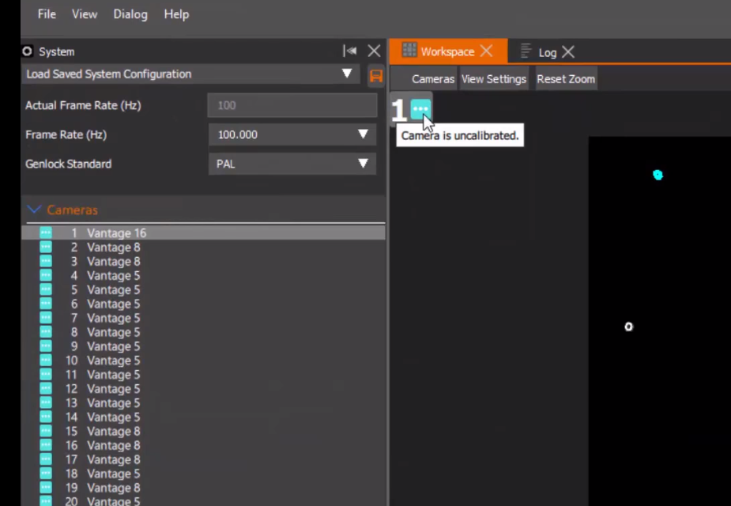
  - Select “System” (bot-right)
  - Hovering the mouse over the 3-dots will show that the camera calibration system is not calibrated.
    - Double-click on a single view to show ALL cameras
      - Noise may show up in your calibration settings.
        - We need to eliminate this…
  - Enter the “Camera Calibration” tab (top-right)
    - Click “Start Masking”
      - Check how the cameras (in the camera view) are capturing the data…
    - In the “Wand” drop-down menu:
      - Choose the type of Wand
        - Click “Show Advanced” (above wand drop-down)
        - Click “Activate Calibration”
          - Check to make sure everything is being capture accordingly
    - Exit “Show Advanced” (Camera calibration)
  - Click “Start Wave”
    - This is a dynamic calibration process
      - Cover the depths AS MUCH AS POSSIBLE
        - Low/high/rotation/translation
      - Keep the LED’s / Markers as visible as possible at all times
        - You will see a percentage meter start to rise…
          - Keeping the numbers within the 1000’s is ideal
          - In the Camera views
            - Flashing Blue, Quickly flashing Blue, Green
              - Begun Calibration
              - Picking up a lot more frames
              - Received enough visual information
  - After wand-wave has been completed
    - Calibration will come out of calibration-mode and dynamically adjust
  - Click “Set Origin”
  - Set the wand flat on the ground
    - Place at least 4-5 extra markers within the space
  - Click “Start Set Floor Plane” (WAIT WAIT WAIT)
    - Inside the Advanced options
      - You can provide an offset (mm)
        - NOW click the “Start Set Floor Plane”
    - You are also able to “Set Floor Extents”
      - Change as necessary
  - Click “Auto Number Cameras”

TUTORIAL #5 – SYSTEM HEALTH AND CAMERA FIXING
- Select the “System” view
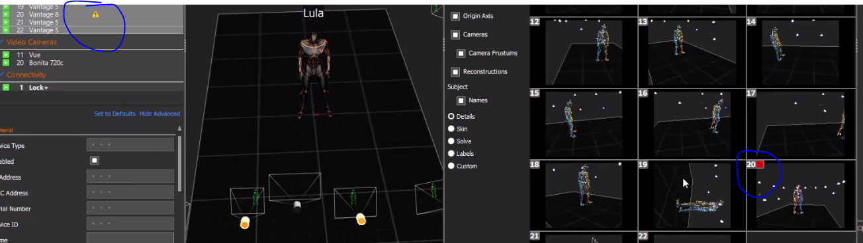
  - You might see a warning of certain cameras

  - Click on the Camera itself
    - Hover over the icon itself and check the warnings
      - Camera Centroid – accuracy of the centroid
      - Temp warning – rising camera temps
- Camera Healing
  - Select the camera in the Camera list (System – Left side)
    - Go to the Camera Calibration (right side)
      - Click “Recover Camera Position”
        - Have your actor move around
        - Wait for it to pick up new frames
      - Re-Click “Recover Camera Position”
        - Camera will now correct itself

