TUTORIAL #1 - INTRODUCTION
INTERFACE
- Open MoBuilder
- Click File >> open
  - Leave at Default for the moment
    - Select “Open”
- Click Layout
  - Click on the “Scripting”
  - Multiple layouts methods
- Along the Bottom
  - Scene Builder
  - Key controls
    - Create keys
    - Determine type of keys
    - Animate things
  - Resources
    - Characters
    - Templates
    - Asset Browser
    - Filters
    - Pose controls
- Center
  - Timeline controls
USER SETTINGS
- “Settings”
  - Interaction Tools
    - Switch between familiar programs to make the interactions easier to manage
  - Preferences
    - Animation
      - Use “Active” keying group
    - Fcurve
      - Use anti-aliasing
      - Show many tangents
  - Fields and Values
    - Accuracy of digits and decimal values
  - OpenGL
  - Recording options
    - Framerates
  - Shading
    - How to shade things while they’re in the viewport
  - Saving
    - Use for saving backup files
    - Save every few minutes
  - View cube
    - “Show” view cube
NAVIGATING IN MOTIONBUILDER
- Go to “Layout”
  - Ctrl+Shift+3
    - Preview
    - Alt+Enter
      - Full Screen
- View >> Perspective
  - Create Camera (under the View drop down menu)
- View >> Orthographic
  - Ctrl-F for Front/Back
  - Ctrl-R for Right/Left
- View >> Viewer Layout
  - Single Pane (ctrl 1)
  - Two Panes (ctrl 2)
  - 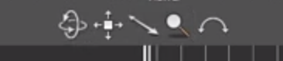Three panes (ctrl 3)
- Navigation tools are along the top of the window

TRANSFORMING OBJECTS
- 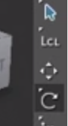Select objects
  - Left click on the Object
    - In the Navigator
      - Objects are arranged in a hierarchy
  - Shift-select exists for multiple objects
- “Shift+D” will empty the selection set
- Along the right side
  - Move (M) , Rotate (R) , and Scale (S)
- Global and Local transform
  - Global
    - Aligned to XYZ of the scene
  - Local
    - Aligned to the XYZ of the object
- “+” or “-“ keys on the numpad
  - Will change the size of the controllers
- Scaling
  - Scale volumetric
    - Maintains the volume of the object
- Menu-sets will change the association of shortcuts

HIERARCHIES
- Use the Navigator to create Hierarchies
  - Select the object and drag it onto the other object
    - It will open a menu
      - Parent
      - Align
      - Rendering Assets
    - Select “Parent”
      - Object will become a “Child” of the parent object
  - To “UnParent”
    - Right click on the object in the scene
      - Select “UnParent”
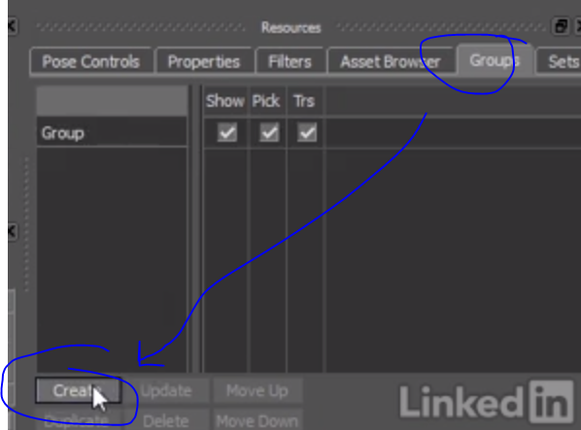GROUPS
- Pick your objects within the scene
  - Go to Groups (bottom right)
    - Click on “Create”
- Options within the Group
  - Show
    - Show the Object
  - Pick
    - Allow “selectability”
  - TRS
    - Allow: Translate / Rotate / Scale
    - Locks in place
- Display
  - 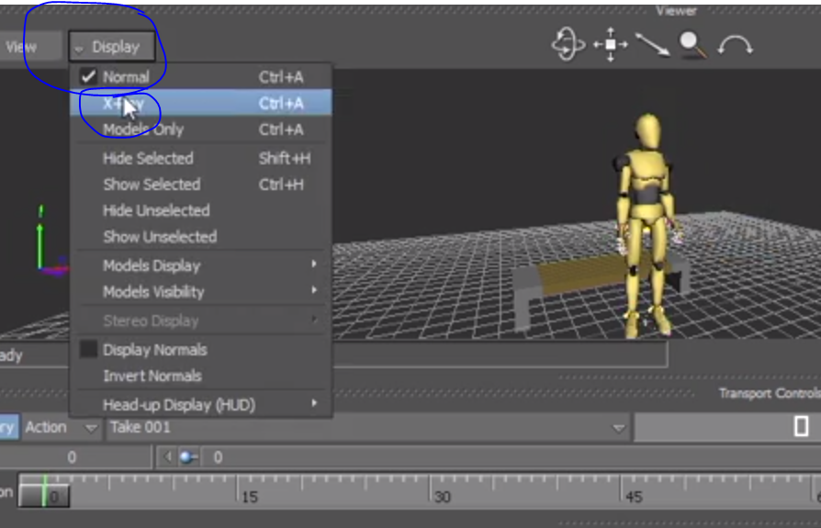Xray
    - Shows the rig
- USE GROUPS!!

TUTORIAL #2 – ANIMATING IN MOTIONBUILDER
TRANSPORT CONTROLS
- Change to Layout >> Preview
  - Press the “Play” button along the timeline
  - 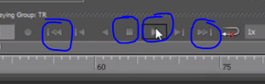Click the “Play” button again to stop
    - Or hit the “Stop” Button
  - Ability to play the scene in reverse
  - Ability to loop the frames
  - Record Button
    - Used for MOCAP
- On the bottom right drop down near the FPS
  - No Snap
    - Fine control of frames
  - Snap on Frames
    - Will play fractional frames
  - Play on Frames
    - Will only play the actual frame
- There’s the ability to control the framerate
  - Right next to the FPS…
    - Control the amount of frames being played
      - 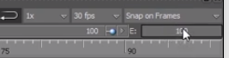¼ speed, ½ speed, 2x speed, etc.
- Control the Start/End frames via the (S: E:)
  - Blue dots also allow you to control the view
of specific frames
- 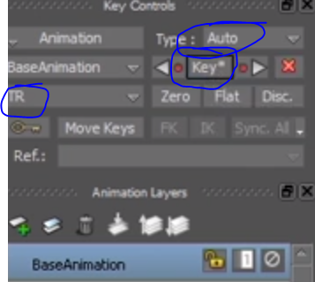If you happen to select an animated object…
  - Animation keys will show up in the timeline
  - Click and move the key frames to edit the timing
- There’s a dropdown menu of the different objects
  - T – translate
  - R – Rotate
  - S – Scale
- Move the timeline and the object as necessary
  - Hit the “Key” button
    - Depending on your T / R / S settings
    - Auto key (directly underneath the TSR setting

ANIMATING WITH KEYS
- Selecting a key “type”
  - Linear / auto / spline / clamped / step / etc.
- Delete a key by
  - Selecting it on the timeline
    - Right click on the timeline and hit Delete

DOPESHEET
- Left-click and drag over the timeline to Marquee select
  - Drag within the green to move all at once
  - Click-drag on beginning / end key to expand/shrink the key selection set
- Bottom left
  - DOPESHEET
    - Brings up detailed view of your animation
    - Shows the T / S / R of all of your keys
    - Can either select the specific keys
      - Or select the Object / Transformation properties to adjust all at once
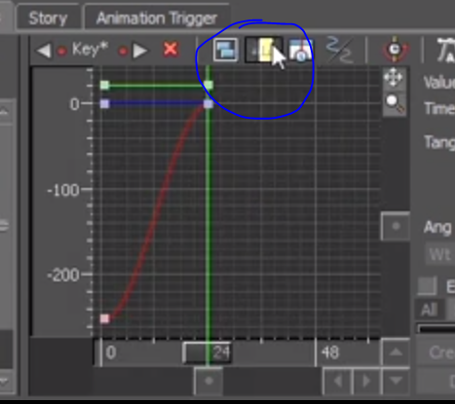ANIMATION CURVES
- FCurves (Bottom left)
  - Can frame the area via these buttons >>>>
- Marquee select the frames you want
  - Use the selection (image) for the different
interpolation options
- Option in the center is to break/un-break tangents
  - 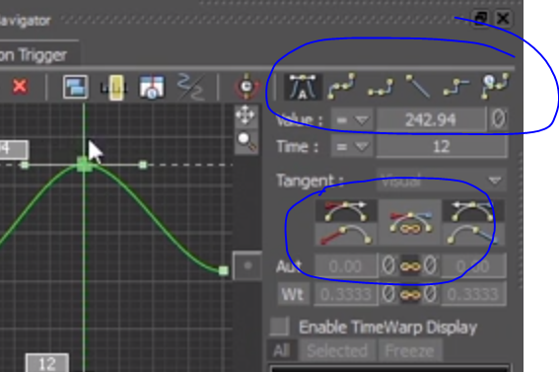Example in photo >>>

CREATING TAKES
- Click on the take…
  - And select a “New” take
- 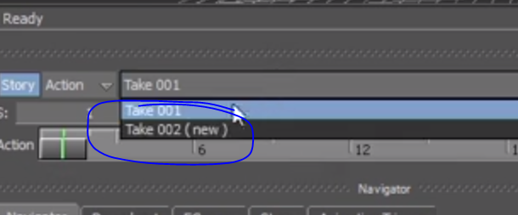Copy the data from the old to the new
  - Select the object you want to animate
  - Use the Navigation tools as necessary
to make the changes for the existing anim.
- Go into the DOPESHEET to delete keys
- Anytime that you select a “new” take…
  - It will select from the current take and make
a new template.
- Keys will only affect the certain “Take” you’re animating in
  - Going back to Take-1 will maintain the original animation

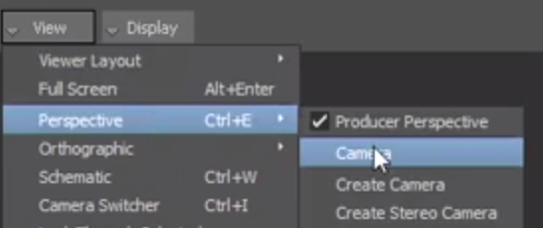TUTORIAL #5 – FINISHING SCENES
LIGHTS AND CAMERAS
- In the Resources panel (Bottom right)
  - >> Asset Browser
    - “Elements” tab
      - Cameras
      - Lights
  - Cameras
    - Click and drag the camera icon into the open area
    - Change the View within the Perspective dropdown
- 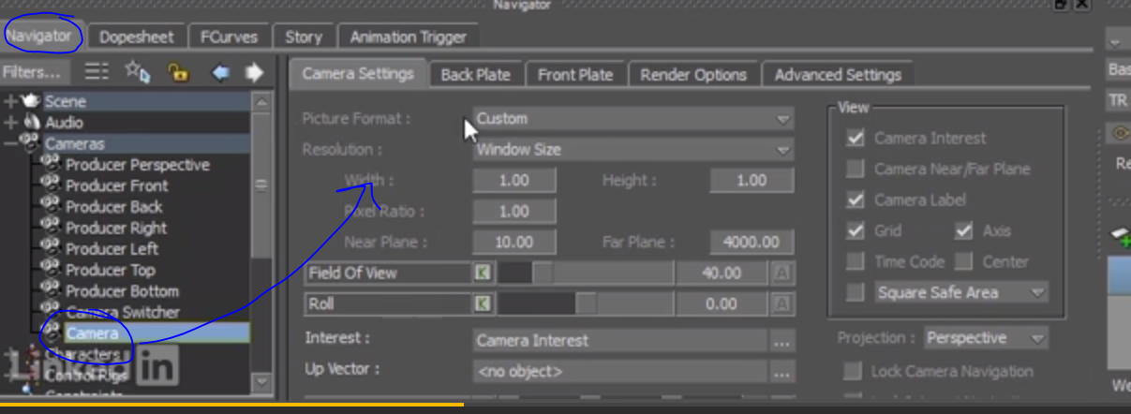You are able to go into the Camera Settings
  - Change the Picture format to HD
    - This will show aspect ratio
- Key your camera as necessary!
- There are the other settings in the Camera tab
  - Back plate
    - Image behind
  - Front Plate
    - Image in front
  - Render options
    - Settings for camera
      - AA
      - Real-time effects
      - DOF
      - Interest (Null object to point camera)
- LIGHTS
  - Click and drag from the Asset Browser
    - Elements
      - Lights
- Select the lights from the Navigator Tab
  - Settings will pop up to experiment with
  - Try doing Ctrl-1 or Ctrl-4 to switch between different views to move the light to a desired position

CREATING A PREVIEW
- 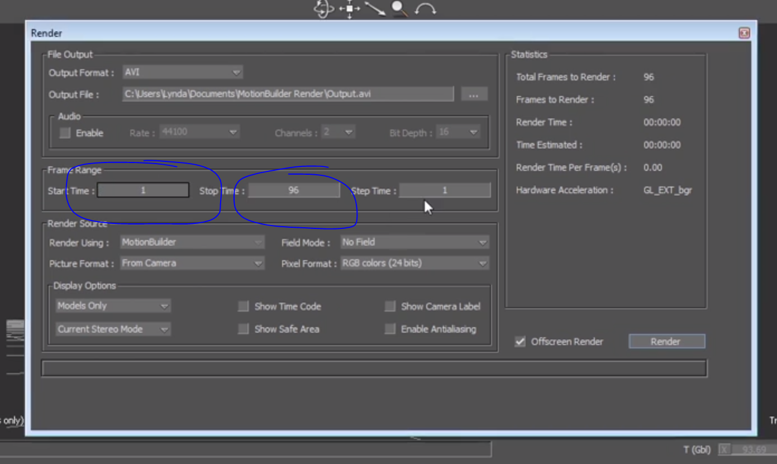Change layout to “preview”
- Go to File >> …
  - Render
  - Check settings
    - Enable AA

EXPORTING SCENES
- File
  - Send to Maya
    - New Scene
    - Send selected objects or your entire scene
- Within Maya
  - Make a change
    - File >> Send to Motionbuilder
      - Update Scene
- Back in MoBuild
  - Scene should be updated!

