Pressure Project #2
- Create a re-telling of a culturally significant story
- Use only visuals and audio (or one/the other)
- Have the story re-told in the range of 1-minute
Ideation:
- AKIRA
  - Use the story of Akira
  - Visuals / Scans of the Manga
  - Have some motion graphics used within the recreation
  - Record audio of the most significant parts
  - Have splits of the Audio
    - Overlap?
    - One by one?
    - Cluttered / clean?
  - Splits?
    - Have movement within the frames?
    - Use AE to create masks and move the imagery around?
      - How many total Images? (6 books)
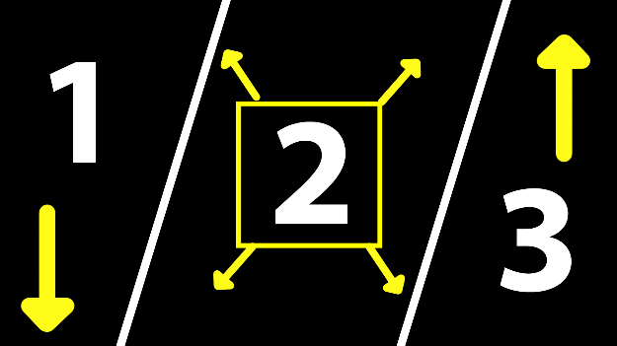
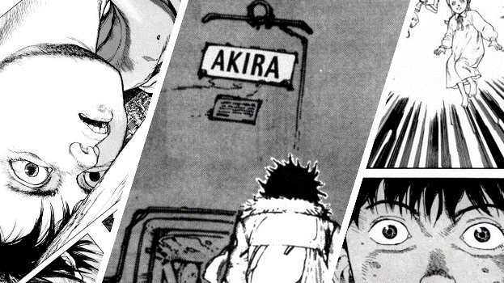
      - 60sec
        - 10sec per book (9 images per book) [#1, #2, #3]
          - [ (3.33sec per book section) * (3 images for 3.33sec) ]
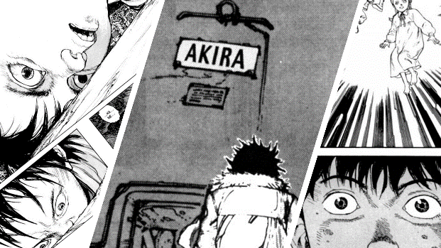
      - 90 images total
      - If I decided to have video in the center…[#2]
        - 3 videos * 6 books = 18 video sections
          - Audio could be derived from the video sections
        - 90 – 18 = 72 Images vs. 90 images.

