Ideation:
- Have visuals move for 10sec / transition / 10sec more visuals / transition / 10sec of visuals / transition / repeat
  - Moving lines
  - Moving shapes
  - Combination of both
  - Repeat and fade back into moving lines

- Have a webcam track movements
  - Move around to activate visuals
  - Have movement tie into how visuals are displayed
    - Red = No movement
    - Orange / Yellow = Little Movement
    - Green = High Movement

- Have a countdown timer (10sec)
  - Have shapes that begin and shrink
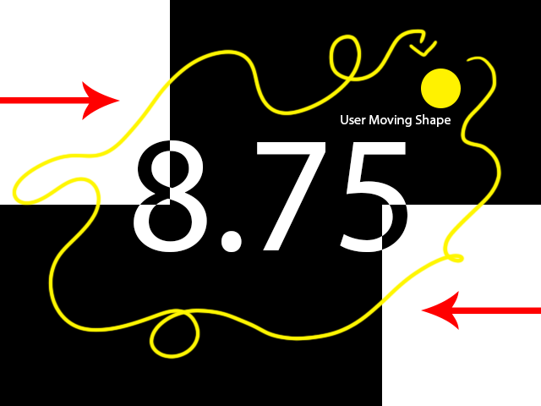
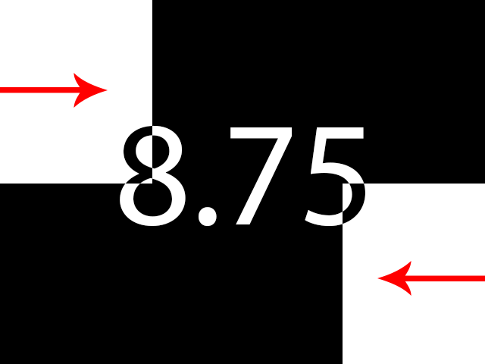
  - Moving around will activate a cube/circle that drags along the screen
    - Once the countdown reaches “ 0.00 “
      - Have the experience play music [FADE IN]
    - Trigger to a screen that says:
      - “Move your body to Draw and fill the space!” [3-SEC]
      - Start with a blank canvas (White (?), black (?), red (?), blue (?) )
      - Give them a 30sec:
        - A hidden timer is already on the canvas that they reveal through ‘drawing’ on the canvas.
        - Timer shrinks numerically as well as in scale as it counts down.
  - If they fill the canvas before the timer runs out:
    - Have a screen that says – “You da best!” [END EXPERIENCE]
      - Play a cheering sound!
  - If they don’t fill the canvas before the timer runs out:
    - Have a screen that says – “Move them hips!” [5 SEC – RETURN TO BEGINNING]
      - Silence the music
    - Repeat from the beginning.
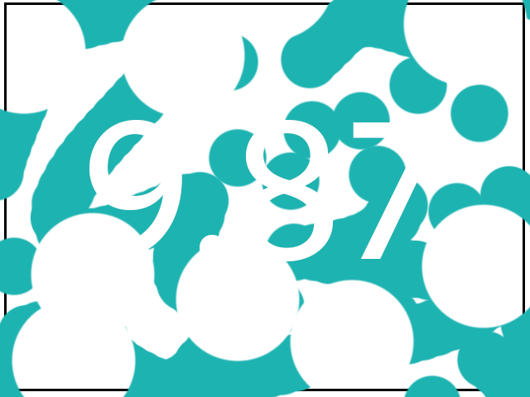
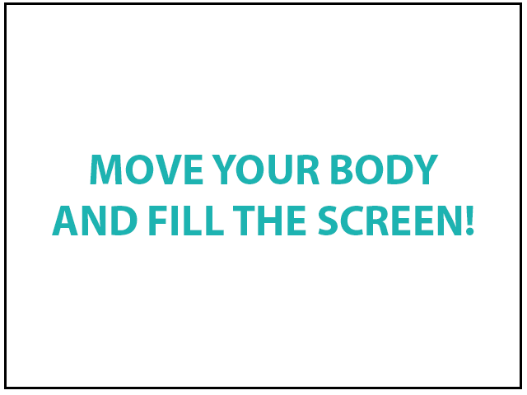

REPEAT EXPERIENCE FROM BEGINNING
END EXPERIENCE
If they fill the screen…
If they don’t fill the screen…

